String Handling
_____________________________________________________________

Q. what is String?
String is a collection of character or it is character array.
Syntax:
char variablename[size];
Example: char name[90];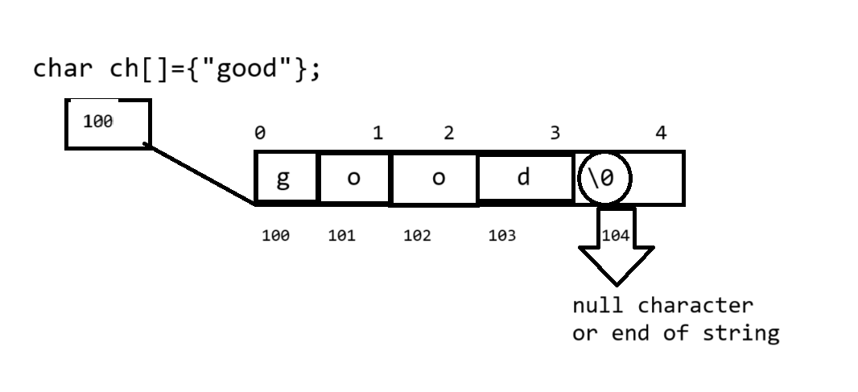

If we want to use string or character array in scanf() and in printf() then we need to use %s modifier

Example: we want to input string from keyboard and display it.
#include<stdio.h>
int main(){
char name[90];
printf("\nEnter string value\n");
scanf("%s",&name);
printf("\nName is %s\n",name);
return 0;
}
Note: when we use scanf() for string input and if we give space in string input then after space input not read by scanf() so if we want to read input with space then we can use gets() function .
gets() function specially design for accept string input so we not need to give format specifier to gets() function like as scanf().

Example: using gets () function
#include<stdio.h>
int main(){
char name[90];
printf("\nEnter string value\n");
gets(name);
printf("\nName is %s\n",name);
return 0;
}

If we want to work with a string we have some inbuilt function provided by c language to us from string.h header file.

int strlen(char[]): this function is used for calculate length of string.

#include<stdio.h>
#include<string.h>
int main(){
char name[90];
printf("\nEnter string value\n");
gets(name);
int l =strlen(name);

printf("\nLength of string is %d\n",l);
return 0;
}

Example: WA to design your own function which is used for calculate length of stirng without using strlen() function

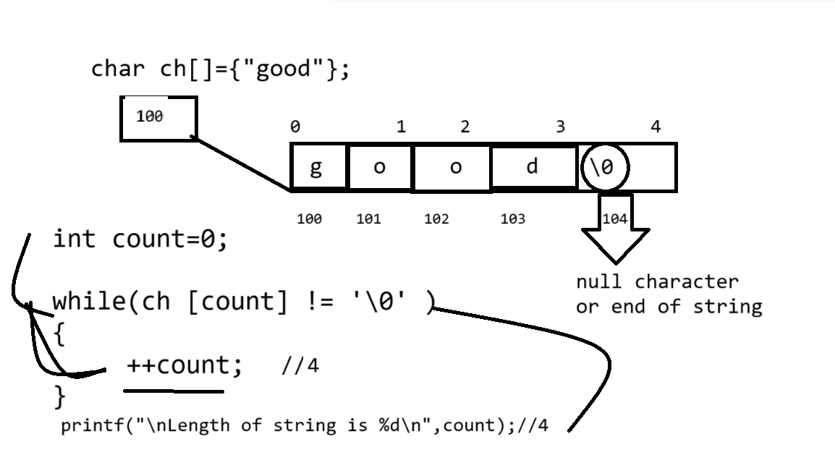
Example:
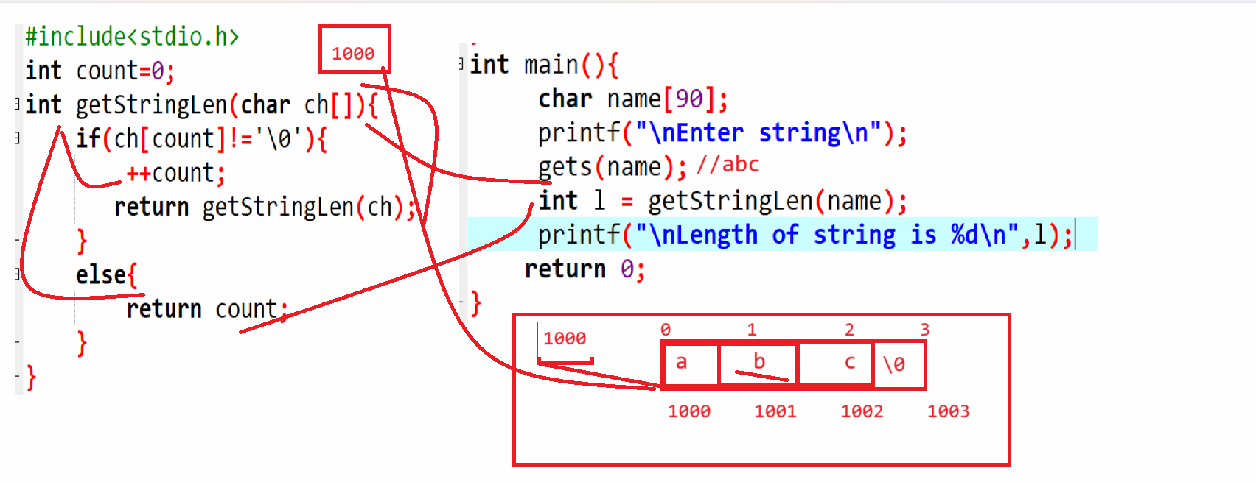

strupr(char[]): this function is used for convert lower case string to upper case string.
#include<stdio.h>
#include<string.h>
int main(){
char name[90];
printf("\nEnter string\n");
gets(name);
printf("\nBefore Covnersion %s\n",name);
strupr(name);
printf("\nAfter conversion %s\n",name);
return 0;
}

Example: Design your own function and accept string as parameter and convert lower case string to upper case string without using strupr()
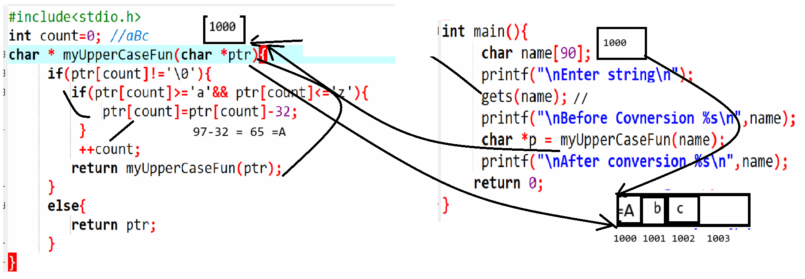

strcat(char[],char[]): this function is used for concat or combine two strings with each other.
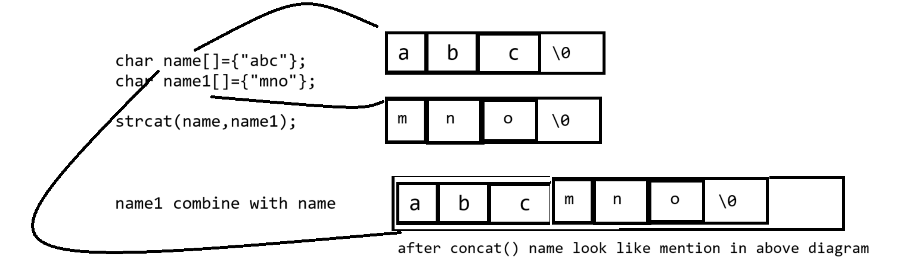

Source code
#include<stdio.h>
#include<string.h>
int main(){
char name[90],name1[90];
printf("\nEnter First string\n");
gets(name);
printf("\nEnter second string\n");
gets(name1);
printf("\nBefore Concat %s\n",name);
strcat(name,name1);
printf("\nAfter concat %s\n",name);
return 0;
}

Example: You have design your own function and pass two strings as parameter and concat them without using any inbuilt function and return resultant string
at function calling point and perform this operation using a recursion
#include<stdio.h>
int count=0;
int getStringLen(char first[]){
int c=0;
while(first[c]!='\0'){
++c;
}
return c;
}
char * myConcat(char first[],char second[],int flen)
{ if(second[count]!='\0')
{
first[flen++]=second[count++];
return myConcat(first,second,flen);
}
else{
return first;
}
}
int main(){
char name[90],name1[90];
printf("\nEnter First string\n");
gets(name);
printf("\nEnter second string\n");
gets(name1);
printf("\nBefore Concat %s\n",name);
int flen=getStringLen(name);
char *ptr = myConcat(name,name1,flen);
printf("\nAfter concat %s\n",ptr);
return 0;
}

strcpy(char[],char[]): this function is used for copy the right hand string value in to left hand string.
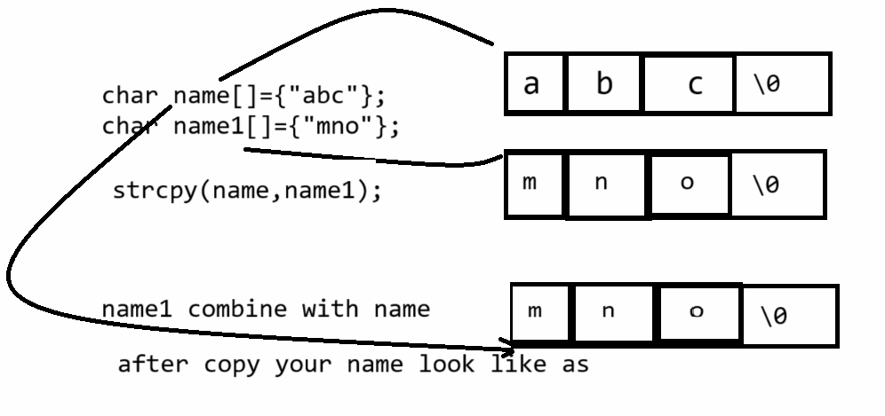

#include<stdio.h>
#include<string.h>
int main(){
char name[90],name1[90];
printf("\nEnter First string\n");
gets(name);
printf("\nEnter second string\n");
gets(name1);
printf("\nBefore Copy %s\n",name);
strcpy(name,name1);
printf("\nAfter Copy %s\n",name);
return 0;
}

strrev(char[]): this function is reverse the string
#include<stdio.h>
#include<string.h>
int main(){
char name[90];
printf("\nEnter string value\n");
gets(name);
printf("\nBefore Reverse %s\n",name);
strrev(name);
printf("\nAfter Reverse %s\n",name);

return 0;
}

Example: WAP to design your own function and pass string in it and perform reverse operation on string without using strrrev() function

#include<stdio.h>
#include<string.h>
char * getRev(char ch[],int len){
int mid=(len/2);
int end=(len-1);
for(int i=0; i<mid;i++){
char temp=ch[i];
ch[i]=ch[end];
ch[end]=temp;
end--;
}
return ch;
}
int main(){
char name[90];
printf("\nEnter string value\n");
gets(name);
printf("\nBefore Reverse %s\n",name);
int l=strlen(name);
char *ptr = getRev(name,l);
printf("\nAfter Reverse %s\n",ptr);

return 0;
}

int strcmp(char[],char[]): this function is used for compare two strings with each other and if string are equal return 0 otherwise return first mismatch character ascii code difference.

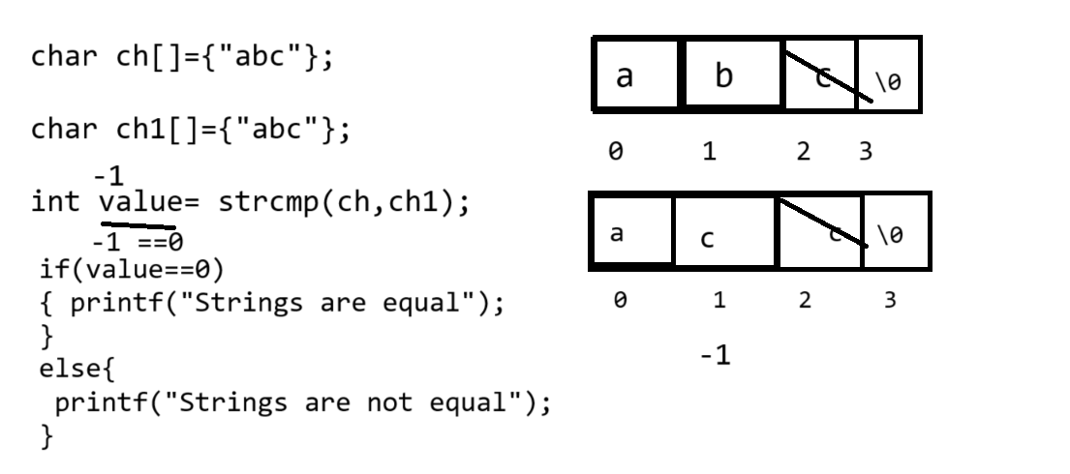

Example:
#include<stdio.h>
#include<string.h>

int main(){
char name[90],name1[90];
printf("\nEnter string value\n");
gets(name);
printf("\nEnter second string\n");
gets(name1);
int value = strcmp(name,name1);
if(value==0){
printf("Strings are eqaul");
}
else{
printf("Strings are not equal");
}

return 0;
}

Example: WAP to input two string values and compare with each other without using strcmp() function
#include<stdio.h>
#include<string.h>
int count=0;
int ownStringComp(char name[],char name1[],int f,int s){
if(f==s){
int count=0,flag=1,diff;
while(name[count]!='\0'){
diff=name[count]-name1[count];
if(diff!=0){
flag=0;
break;
}
++count;
}
return flag==1?0:diff;
}
else{
return -1;
}
}
int main(){
char name[90],name1[90];
printf("\nEnter string value\n");
gets(name);
printf("\nEnter second string\n");
gets(name1);
int f=strlen(name);
int s=strlen(name1);
int result=ownStringComp(name,name1,f,s);
if(result==0){
printf("Strings are equal");
}
else{
printf("Strings are not equal");
}

return 0;
}

Example: WAP to input two strings and check strings are anagram or not
Input: abc
Input: bca
Output: Anagram string

Source code
#include<stdio.h>
#include<string.h>
int checkAnagram(char first[],char second[],int f,int s){
int flag=1;
if(f==s){
for(int i=0;i<f;i++){
for(int j=(i+1);j<f;j++){
if(first[i]>first[j]){
char temp=first[i];
first[i]=first[j];
first[j]=temp;
}
if(second[i]>second[j]){
char temp=second[i];
second[i]=second[j];
second[j]=temp;
}
}
}

//perform comparision
for(int i=0;i<f;i++){
if(first[i]!=second[i])
{ flag=0;
break;
}
}
return flag?1:0;
}
else{
return 0;
}
}
int main(){
char name[90],name1[90];
printf("Enter first string\n");
scanf("%s",&name);
printf("\nEnter second string\n");
scanf("%s",&name1);
int f=strlen(name);
int s=strlen(name1);
int result=checkAnagram(name,name1,f,s);
if(result){
printf("Strings are anagram");
}
else{
printf("Strings are not anagram");
}

return 0;
}

Two dimensional Strings
______________________________________________________________
Two dimensional string help us to work with multi line text

Example of single dimensional string
char name[90];//single line with 90 characters.
Example of two dimensional string
__________________________________________________
char name[5][90] ;//5 lines with 90 characters.

Following diagram shows how two dimensional string store in memory.
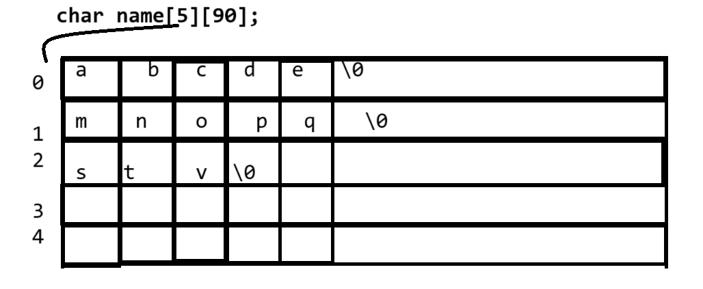
When we work with two dimension string in c language we have only one loop
Required

Following code demonstrate how to use two dimensional string loops.
___________________________________________________________________
#include<stdio.h>
#include<string.h>
int main(){
char first[5][90];// college -
printf("\nEnter data in strings\n");
for(int i=0;i<5;i++){
gets(first[i]);
}
printf("\nDisplay string values\n");
for(int i=0; i<5;i++){
printf("%s\n",first[i]);
}

return 0;
}

